CUSTOMER SEGMENTATION ANALYSIS
USING K-MEANS CLUSTERING



K SHRUTI SURESH BABU

DON BOSCO ARTS & SCIENCE COLLEGE
ANGADIKADAVU, IRITTY
KANNUR – 670706

2022-2024

CUSTOMER SEGMENTATION ANALYSIS
USING K-MEANS CLUSTERING

DISSERTATION SUBMITTED TO THE KANNUR UNIVERSITY
IN PARTIAL FULFILLMENT OF THE REQUIREMENT
FOR THE AWARD OF THE PG OF
MASTERS OF STATISTICS WITH DATA ANALYTICS

BY
K SHRUTI SURESH BABAU
REGISTER NO: C2PSDA1002

UNDER THE GUIDANCE OF
MS. SHAHANA SHIRIN
HEAD OF DEPARTMENT

DEPARTMENT OF STATISTICS
DON BOSCO ARTS & SCIENCE COLLEGE
ANGADIKADAVU, IRITTY, KANNUR-670706
NOVEMBER 2024

i
DEPARTMENT OF STATISTICS
DON BOSCO ARTS & SCIENCE COLLEGE
ANGADIKADAVU, IRITTY, KANNUR

CERTIFICATE
This is to certify that the dissertation entitled CUSTOMER SEGMENTATION ANALYSIS USING K-MEANS CLUSTERING submitted by K SHRUTI SURESH BABU , in partial fulfilment of the requirement for the award of the MASTER OF STATISTICS WITH DATA ANALYTICS , is a bona fide record of work done under the guidance and supervision of Ms. SHAHANA KABEER , Head of Department during the period of her study (2022-2024) in the Department of Statistics, Don Bosco Arts and Science College, Angadikadavu , Iritty , Kannur, affiliated to The Kannur University.

MS. SHAHANA SHIRIN
Head, Department of Social Work
Don Bosco Arts and Science College

ii
DEPARTMENT OF STATISTICS
DON BOSCO ARTS & SCIENCE COLLEGE
ANGADIKADAVU, IRITTY, KANNUR

CERTIFICATE

This is to certify that the dissertation CUSTOMER SEGMENTATION ANALYSIS USING K-MEANS CLUSTERING submitted by K SHRUTI SURESH BABU, in partial fulfilment of the requirement for the award of the MASTERS OF STATISTICS WITH DATA ANALYTICS , is a bonafide record of work done under my guidance and supervision during the period of her study (2022-2024) in the Department of Statistics , Don Bosco Arts and Science College, Angadikadavu , Iritty , Kannur, affiliated to the Kannur University.

MS. SHAHANA SHIRIN
Head of Department of Statistics and Guide
Department of Statistics
Don Bosco Arts and Science College
iii
DECLARATION

I, Ms. K SHRUTI SURESH BABU , the undersigned, hereby declare the dissertation entitled, CUSTOMER SEGMENTATION ANALYSIS USING K-MEANS CLUSTERING submitted to the Kannur University, in partial fulfilment of the requirement for the award of the PG of Masters of Statistics With Data Analytics , is a Bonafide work done by me under the guidance of Ms. Shahana Shirin, Head of Department, Department of Statistics, Don Bosco Arts and Science College, Angadikadavu , Iritty. This work has not been placed by anybody in the University for the Award of any degree or diploma.

ANGADIKADAVU, IRITTY K SHRUTI SURESH BABU
NOVEMBER 2024

Iv
ACKNOWLEDGEMENT

I owe my sincere gratitude to Dr. Fr. Francis Karakkat, Principal Don Bosco Arts and Science College Angadikadavu , Iritty having given permission to conduct a research work in the Institute.
I extend my heartfelt thanks to Ms. Shahana Shirin, Head of the Department of Statistics, Don Bosco Arts and Science College Angadikkadavu for the constant support, constant motivation and inspiring guidance to complete my thesis work.
I owe my gratitude to my research guide Ms. Shahana Shirin, Head Of Department, Department of Statistics, Don Bosco Arts and Science College Angadikkadavu, Iritty for her relentless effort, valuable suggestions, encouraging me to maintain my enthusiasm towards the thesis process from the beginning.
I would like to thanks the faculties and friends from Department of Statistics for their love, help and support as and when I needed it. My sincere thanks to all respondents for the help and they provided me in every possible way.

K SHRUTI SURESH BABU

V
Abstract

Compelling choices are compulsory for any organization to produce good revenue. Nowadays contest is huge and all organizations are moving forward with their own different strategies. We ought to utilize information and take an appropriate choice. Each individual is different from the other and we don't know what he/she purchases or what their likes are. However, with the assistance of the machine learning method, one can sort out the information and can find the target group by applying a few algorithms to the dataset. Without this, It will be very troublesome and no better techniques are accessible to find the gathering of people with comparable person and interests in an enormous dataset. Here, The customer segmentation utilizing K-Means clustering assists with gathering the information with the same ascribes which precisely helps to business the best. We are going to use the elbow technique to track down the number of clusters and finally, we visualize the data.

vi
CONTENTS

TITLE /COVER PAGE i
CERTIFICATES ii
DECLARATION iv
ACKNOWLEDGEMENT v
ABSTRACT vi
CONTENTS vii
CHAPTER 1: INTRODUCTION
  - INTRODUCTION………………………………………………………………………........1
  - DATASET OVERVIEW…………..………………………………………………………….2
  - PROBLEM STATEMENT…………………………………………………………………..3
  - OBJECTIVE …………………………………….…………………………………………......3
CHAPTER 2: LITERATURE REVIEW OF LITERATURE……………………………. 4
CHAPTER 3: TECHNIQUIES AND TERMINOLOGIES USED
3.1 MACHINE LEARNING……………………………………………………………………...6
3.2 PYTHON……………………………………………………………………………………..….7
3.3 JUPYTER NOTEBOOK ……………..………………………………………………..……8
3.4 COUNT PLOT………………………………………………………………………….………8
3.5 DISTPLOT……………………………………….…………………………………….……..…8
3.6 CATPLOT…………………..……………………………………………………….….……….8
3.7 SWARMPLOT…………………………………………………………………….…………..8
3.8 VIOLIN PLOT…………………………………………………………………….……………8
3.9 BOX PLOT……………………………………………………………………….……………..9

vii
3.10 HEATMAP……………………………………………………………………..9
3.11 CLUSTERING…………………………………………………………………9
3.12 K-MEANS CLUSTERING…………………………………………………10
3.13WITHIN CLUSTER SUM OF SQUARES…………………………….10
3.14 ELBOW METHOD…………………………………………………………11
3.15 2D SCATTER PLOT………………………………………………………..11
3.16 3D SCATTER PLOT………………………………………………………..11
3.17 PRINCIPAL COMPONENT ANALYSIS………………………………12
CHAPTER 4 : METHODLOGY………………………………………………13
CHAPTER 5: RESULTS AND INSIGHTS…………………………………33
CHAPTER 6: CONCLUSION
6.1 SUMMARY OF INSIGHTS………………………………………………..38
6.2 RECOMMENDATIONS…………………………………………………….38
6.3 LIMITATIONS…………………………………………………………………39
6.4 FUTURE WORK……………………………………………………………..40
REFERENCES…………………………………………………………………….41

viii
CHAPTER 1: INTRODUCTION
1.1 Introduction
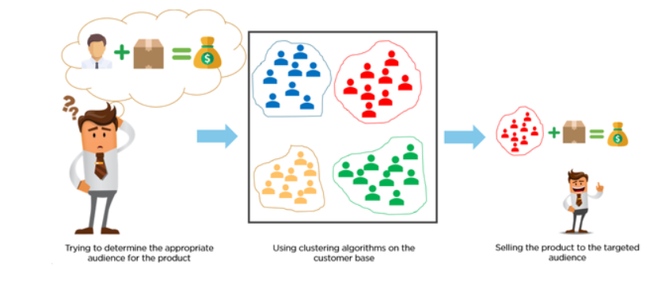
Management of customer relationship has always played a vital role to provide business intelligence to organisations to build, manage ,develop valuable long term customer relationships. The importance of treating customers as an organizations main asset is increasing in value in present day and era. Organizations are investing rapidly in the development of customer acquisition, maintenance and development strategies. The business intelligence has a vital role to play in allowing companies to use technical expertise to gain better customer knowledge and Programs for outreach. By using clustering techniques, customers with similar means are clustered together. Clustering is a type of exploratory data mining that is used in many applications, such as machine learning, classification and pattern recognition.
Customer segmentation is a strategic approach that involves dividing a customer base into smaller, more manageable groups based on shared characteristics. By understanding the unique needs, preferences, and behaviours of each segment, businesses can tailor their marketing efforts, products, and services to deliver a more personalized and effective experience. The goal of customer segmentation is to create homogeneous groups of customers based on various attributes ,such as demographics , purchasing behaviours, preferences and needs. Different methods and machine learning algorithms, such as K-Means clustering and hierarchical clustering are often
1
employed to group customers effectively. This segmentation process helps to identify distinct customer segments, enabling companies to allocate resources efficiently and focus on the most profitable opportunities. This allows them to create targeted marketing campaigns, such as offering exclusive discounts to frequent shoppers or promoting specific products to young adults.
Customer segmentation is not a one-time activity but rather an ongoing process that requires continuous monitoring and adjustment. As customer needs and preferences evolve, businesses must adapt their segmentation strategies to stay relevant and effective.
1.2 Dataset Overview
You are owing a supermarket mall and through membership cards , you have some basic data about your customers like Customer ID, age, gender, annual income and spending score. Spending Score is something you assign to the customer based on your defined parameters like customer behaviour and purchasing data. In this project, we perform customer segmentation using the Mall Customer Dataset. It consist of 5 features of 200 customers. The dataset serves as a case study to demonstrate how segmentation can help retailers understand customer preferences and behaviours. The key attributes included in the dataset are:
- CustomerID: Unique identifier for each customer.

- Gender : Gender of the customer.

- Age: Age of a customer

- Annual Income(k$): Annual Income of the customer in thousands of dollars

- Spending Score (1-100): Score assigned by the mall based on the mall based on the customer’s spending habits.

2

1.3 Problem Statement
You own the mall and want to understand the customers like who can be easily be the Target Customers so that the sense can be given to marketing team and plan the strategy accordingly.
Customer Segmentation is the best application of unsupervised learning. Using clustering, identify segments of customers in the dataset to target the potential user base. They divide customers into various groups according to common characteristics like gender, age, interest, and spending habits so they can market to each group effectively. Use K-Means Clustering and also visualize the gender and age distributions. Then analyse their annual income and spending scores. As it describes about how we can divide the customers based on their similar characteristics according to their needs by using k-means clustering which is a classification of unsupervised machine learning.

1.4 Objective Of This Project
The main objectives are:
- Identify customer segments
- Understand customer needs
- Create effective pricing strategies
- Increase customer satisfaction.
- Demonstrate the use of machine learning
By the end of this case study , you would be able to answer below questions.
- How to achieve customer segmentation using machine learning algorithm (K-Means Clustering) in Python in simplest way.
- Who are your target customers with whom you can start marketing strategy (easy to converse)
- How the marketing strategy works in real world.

3
CHAPTER 2: LITERATURE REVIEW
In this chapter of our report, we’ve discussed some of the previous research papers that we’ve looked into. Here are few of them:
- In the research paper [1] Sari J N ,Nugroho L E , Ferdiana R and Santosa P I mainly discusses about the customer segmentation techniques. In today’s world many people are shopping with ecommerce and many companies using ecommerce to promote or to sell their products. This article mainly reviews customer segmentation from data ,methods and process. It explains the type of data like internal and external data needed, different methods that are classified into Simple techniques, RFM technique, Target technique and Unsupervised technique. It also discuss different process like defining business objectives, data collection ,data preparation, variable analyse , data preprocessing and performance evaluation.
- According to Chenguang Wang [2], for an efficient customer segmentation an unsupervised deep learning model called Self Organizing Map with an improved social spider optimization approach can be used. The customer data are analysed by a feature engineering process using swarm intelligence model called Modified Social Spider Optimization to select the behavioural factors of the customer .Then the customers are clustered using Self Organizing Neural Network (SONN).Based on the clusters , the customers are classified using Deep Learning Network(DNN) model.
- In this paper [3], it mainly presents the data mining process by combining RFM model with K-Mean ,K-Medoids and DBSCAN algorithm. The paper analyses transaction data lines to identify potential customers. The K- Means ,K-Medoids and DBSCAN algorithm are very sensitive for initializing the cluster centre because it is done randomly. The trial process in K-Means and K-Medoids method is done using random centroid values and at DBSCAN is done using random Epsilon and Min points .The results showed that K-Means had the best level of validity than K-Medoids and DBSCAN .According to this paper, the best number of clusters obtained by using these algorithms provide the Dormant and Golden customer classes.
4
- The research paper [4] is based on to identify telecom customer segmentation by using machine learning approach(K-Means) into meaningful and labelled segments and develop a web based dashboard. Subsequently ,”INSIGHT”-an interactive web based dashboard was developed to assist telecom managers to understand customers and advance their business decision. The interactive dashboard provides analysis of customer segments based on demographics, behavioural ,and regional traits and also to devise customized query for deeper analysis. Hence with this the telecom could target their customers accurately based on their needs and preferences to increase service satisfaction.

- In the research paper [5],it combines K-Means with elbow method to determine the actual number of clusters customer profiling segmentation in SME .The value on K will continue to increase in each process and decrease with great value. The graph shows the elbow n of all the K-values obtained. The research also finds the best value of K by using elbow method. The elbow method is easy to implement by looking at the ideal K value graph with the position on the elbow along with the SSE(sum of squares error) which is less than 1. The best cluster K result will be the basis for clustering. The result of determining the best number of clusters with the elbow method will be the default for characteristic process based on case study.

- According to Medicana A, Evaristus D M, and E Miranda this paper [6] builds a clustering models on customer profile data based on their usage of internet banking in XYZ bank. The clustering method employed K-Means ,K-Medoids based on RFM score of customer’s internet banking transactions. This research is uses knowledge discovery method. The main goal of this research was to compare the performances of both clustering methods in customer segmentation. After the result was measured and compared we get K-Means outperformed K-Medoids method.

5
CHAPTER 3: Techniques and Terminologies Used
In this chapter we will cover the important techniques and terminologies used in this project.
3.1 Machine Learning
Machine learning (ML) is a branch of artificial intelligence that allows computers to learn from and make decisions based on data without being explicitly programmed. It uses algorithms to find patterns in data, enabling predictions or decisions without human intervention.
Types of machine learning:
- Supervised learning: The algorithm is trained on labeled data, where the correct output is provided for each input. Examples include classification (e.g., identifying spam emails) and regression (e.g., predicting house prices).
- Unsupervised learning: The algorithm is trained on unlabeled data, and it must discover patterns and relationships within the data itself. Examples include clustering (e.g., grouping customers based on their behavior) and dimensionality reduction (e.g., simplifying complex data).
- Reinforcement learning: The algorithm learns by interacting with an environment and receiving rewards or punishments based on its actions Examples include game-playing and robotics.
In this project, unsupervised learning methods, specifically K-means clustering, were used to automatically segment customers into distinct groups based on their behaviour and attributes. In unsupervised learning, the goal is to group similar data points together based on their features. The algorithm identifies clusters or groups that share similar characteristics. This is particularly useful when you don't know in advance how to classify the data or when you're trying to find hidden structures or patterns in the data.

6
3.2 Python
Python is a general-purpose programming language known for its simplicity and extensive libraries that facilitate data analysis, machine learning, and visualization . It offers numerous libraries. In this project, Python was used to perform data preprocessing, visualization, and clustering analysis for customer segmentation. The main libraries used in this analysis are:
- Pandas
A powerful data manipulation and analysis library that provides data structures like Data Frames for handling structured data.

- NumPy
Provides support for numerical operations and working with arrays.

- Seaborn
A statistical data visualization library built on top of Matplotlib that makes it easy to create informative and attractive graphics.

- Matplotlib
A comprehensive library for creating static, animated, and interactive visualizations in Python.

- mpl_toolkits.mplot3d
A toolkit for 3D plotting in Matplotlib. It is a part of the matplotlib package. So it doesn’t require installation.

- %matplotlib inline
A Jupyter notebook magic command that allows for inline display of Matplotlib plots.

- Warnings
A built-in Python module to control the display of warnings that may arise during code execution. It comes with python by default and so it doesn’t need to be installed.

7

3.3 Jupyter Notebook
Jupyter Notebook is an interactive development environment that allows users to write code, run it, and see the results immediately, all in one place. It is particularly useful for data analysis and machine learning projects, enabling easy integration of code, visualizations, and explanatory text. This project was implemented and documented using Jupyter Notebook, making the analysis transparent and well-organized.
  - . Count plot
A count plot is used to show the counts of observations in each categorical bin using bars. It is helpful for visualizing the frequency distribution of categorical variables. In this project, count plots were used to observe the distribution of customer segments.
3.5. Distplot
A distplot combines a histogram and a kernel density estimate (KDE) to visualize the distribution of a dataset. It provides insights into the data's underlying distribution and helps identify any skewness. Distplots were utilized to understand the distribution of numerical features in the dataset.
3.6. Catplot
A catplot is a general plot that allows different types of categorical plots (such as box, violin, etc.) based on the kind of relationship between categorical and numerical data. This was used to visualize relationships between the customer segments and other numerical attributes.
  - . Swarmplot
Swarmplots are a categorical scatter plot that arranges the points non-overlapping, showing the distribution of values within categories. In this project, swarmplots were used to depict the distribution of numerical data points for various customer groups.
3.8 Violin Plot
A violin plot is a combination of a box plot and a KDE plot. It provides a summary of the data distribution, showing both the probability density of the data and a summary through a box plot. It was used in this project to compare the distribution of different numerical features across customer segments.
8
In the project, The catplot function with kind='violin' creates the basic violin plot structure, showing the distribution of 'Spending Score' across different 'Gender' categories.
The swarmplot function is used to add individual data points to the violin plot, providing a more granular view of the data distribution.
  - Box Plot
A box plot, also known as a whisker plot, provides a summary of the data's five-number summary: minimum, first quartile (Q1), median, third quartile (Q3), and maximum. It helps in identifying outliers and comparing the distribution between different groups. Box plots were used in this analysis to assess the spread and central tendency of customer-related features.
  - Heatmap
A heatmap is a graphical representation of data where individual values are represented as colours in a matrix format. It is particularly useful for visualizing the magnitude of a phenomenon as it varies across two dimensions, allowing for quick insights into patterns, correlations, and trends within the data.
Heatmaps are commonly used to display relationships between variables in a dataset, making it easier to identify areas of high and low concentration. They can effectively highlight correlations, helping to discern how different features interact with one another.
In this customer segmentation analysis, a heatmap was utilized to visualize the correlation between various customer attributes such as age, income, and spending score. This visualization provided insights into which features are closely related, guiding the clustering process and improving the understanding of customer behaviour.
3.11 Clustering
Clustering is a machine learning technique used to group similar data points into clusters. It is an unsupervised learning method, meaning that it works on unlabeled data. In this project, clustering was applied to identify patterns and segment customers into distinct groups based on their behaviour and preferences.
9

3.12 K- Means clustering
K Means algorithm in an iterative algorithm that tries to partition the dataset into K predefined distinct non overlapping sub groups which are called as cluster.
Here K is the total no of clusters. Every point belongs to only one cluster. Clusters cannot overlap.
Steps of K-Means Algorithm
The K-means algorithm is an iterative clustering technique used to divide a dataset into 'K' distinct, non-overlapping clusters. The algorithm works as follows:
- Randomly select 'K' initial cluster centroids (starting points).
- : Assign each data point to the nearest centroid based on Euclidean distance. This step forms 'K' clusters.
- Calculate the new centroid for each cluster by averaging the data points in each cluster.
- Repeat the assignment and update steps until the centroids no longer change significantly or a maximum number of iterations is reached.
The goal is to minimize the Within-Cluster Sum of Squares (WCSS), which is the sum of squared distances between each data point and its centroid. The algorithm continues until it converges to the most compact and distinct clusters.
In this project, the K-means algorithm was used to segment customers into distinct groups based on their attributes, such as spending behavior and preferences.
3.13 WCSS (Within-Cluster Sum of Squares)
WCSS is a measure used in clustering to calculate the sum of the squared distances between each data point and its corresponding centroid within a cluster. It is an important metric to evaluate the compactness of clusters. Lower WCSS values indicate that the clusters are more tightly packed. This metric was used in the project to assess the quality of the clusters formed by the K-means algorithm.
10
Mathematically, WCSS is expressed as:
WCSS =$\sum_{i=1}^{k}{\sum_{{x∈C}_{i}}{{ IIx - μII}^{2}}}$
k is number of clusters.
$C_{i}$ is the $i^{th}$ cluster
x denotes the data points in cluster $C_{i}$
$μ_{i }$is the centroid of cluster $C_{i}$
${ IIx - μII}^{2}$ is the squared Euclidean distance between x and $μ_{i }$.
3.14 Elbow Method
The Elbow Method is used to determine the optimal number of clusters (K) for K-means clustering. By plotting WCSS values for different values of K, the "elbow point" is identified, where adding more clusters does not significantly decrease WCSS. This point suggests the best number of clusters for the data. In this project, the Elbow Method was applied to decide the optimal number of customer segments.
3.15 2D Scatter Plot
A 2D scatter plot is a graphical representation of data points in two dimensions, where each point is plotted along the x and y axes based on two features. Scatter plots are useful for visualizing the relationships between two variables. In this project, 2D scatter plots were used to visualize the distribution of customers across two selected features (such as annual income and spending score).

3.16 3D Scatter Plot
A 3D scatter plot is an extension of the 2D scatter plot, adding a third axis (z-axis) to represent an additional feature. This allows for a more detailed visualization of the relationships between three variables at once. In this project, 3D scatter plots were used to explore the clustering of customers based on three features, providing a more comprehensive view of the customer segmentation.

11
3.17 Principal Component Analysis
Principal Component Analysis (PCA) is a statistical procedure that uses an orthogonal transformation that converts a set of correlated features to set of linearly uncorrelated features. These new transformed features are called the Principal Components. Moreover PCA is unsupervised learning algorithm that is used for the dimensionality reduction in Machine Learning. It is a technique to draw strong patterns from the given dataset by reducing the variances.
PCA generally tries to find lower-dimensional surface to project the high-dimensional data. It is a feature extraction technique so it contains the important variables and drop the least important variable.
Steps in PCA:
- Standardize the data: Since PCA is affected by scale, standardize the features to have mean 0 and variance 1.
- Compute the covariance matrix: This captures how the features in the dataset vary with respect to each other.
- Compute the eigenvectors and eigenvalues: These are derived from the covariance matrix. Eigenvectors (principal components) determine the directions of the new feature space, and eigenvalues give the magnitude of variance in those directions.
- Select principal components: Sort the eigenvalues in descending order and choose the top components that capture the most variance (based on the cumulative variance explained).
- Transform the data: Project the original data onto the selected principal components to reduce dimensionality.

12
CHAPTER 4: METHODLOGY
The following steps outline the methodology for conducting a K-means customer segmentation analysis:
- Data Collection
As mentioned above in the introduction the dataset used here is Mall Customers dataset. It consist of information about customers such as Customer ID, Gender, Age ,Annual Income and Spending Score.

- Installing Libraries
For performing analysis we need to install certain python libraries.
To install these libraries, we use the following command:
pip install pandas numpy seaborn matplotlib

- Importing Libraries
To begin with the analysis, first we need to import certain python libraries

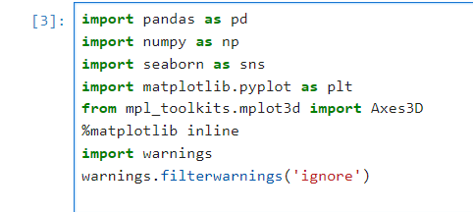

- Loading The Dataset
After importing libraries, we then load the dataset Mall_Customers in the environment . We load it with the help of pandas library

13
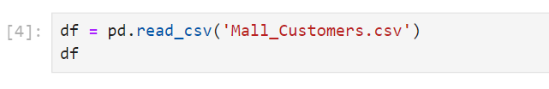
The Dataset with 5 features of 200 customers is loaded.
- Data preprocessing
Data preprocessing is a process of cleaning, organizing and transforming the raw data before it is used for analysis. The goal of data preprocessing is to improve the quality of the data and to make more suitable for analysis.
  - Dataset Overview
To check whether the dataset is loaded, we take few rows from the Mall Customers. For this we use head() function.

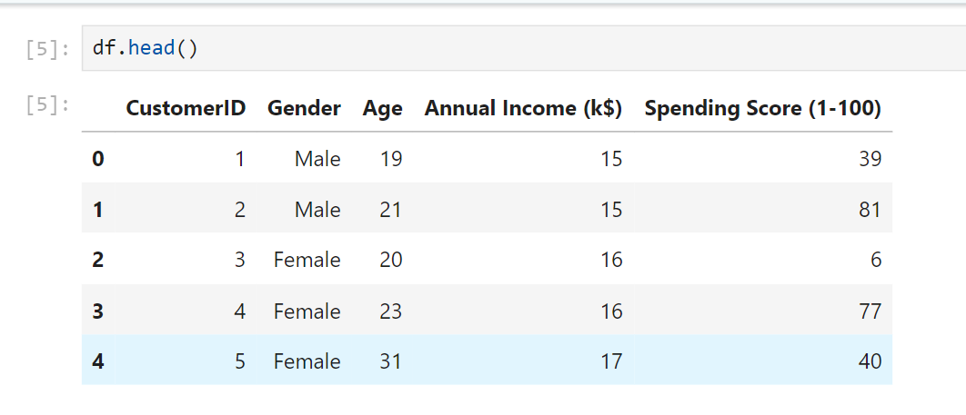
It will load the first 5 data. This data gives an idea of how our dataset looks like.
  - Dataset Shape
The dimension of our dataset is checked using shape to understand the number of rows and columns.

14
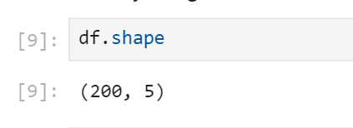
From this we understood thar our dataset is consist of 200 columns and 5 rows.
  - Checking for the missing values
After getting an idea of dataset we now check whether our dataset is complete or have any values missing. It is a very important step. If missing values are not handled carefully, they may result in an incorrect prediction. This can be handled by deleting the row or by calculating the mean of the row or column where the values are missing. This is checked using isnull() .sum() function.
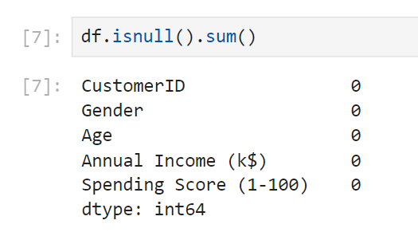
The result shows that there are no missing values in the dataset. This confirmed that further data cleaning is not required for missing values.
  - Data Information
The dataset information is required to check the datatypes of each column and number of non-null values in each. For this we use the function info().
15

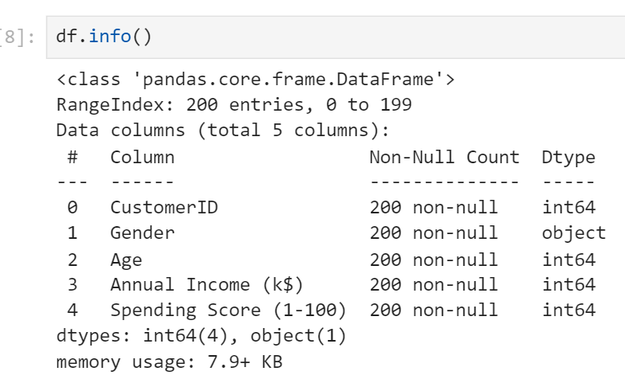
From the result displayed, we understood that the dataset is stored efficiently with numeric variables as integers and categorical data(gender) as an object(string). This ensures the data is ready for further analysis.
  - Data Renaming
We will now rename the columns “Annual Income(k$)” and “Spending Score(1-100)” to Annual Income and Spending Score for easy preference.

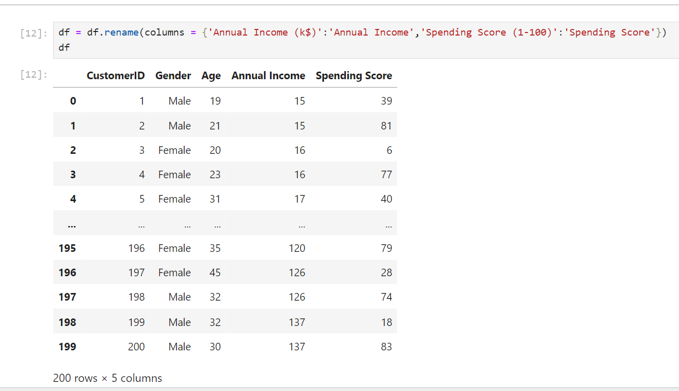
16
6 . Exploratory Data Analysis (EDA)
Exploratory Data Analysis is a process used for analysing and summarizing the main characteristics of data set often with the help of visualization methods . Its purpose is to identify relationships between variables, discover patterns, check assumptions and spot anomalies. EDA helps in further modelling and analysing. EDA is an important first step in any data analysis.
EDA techniques include descriptive statistics (mean, median, mode) ,Visualization(histograms, box plot, scatter plot, and pair plot) and correlation analysis to study relationships between variables.
  - Summary Statistics
Next we generate a summary statistics for the dataset to provide insights into mean and variability of the data.

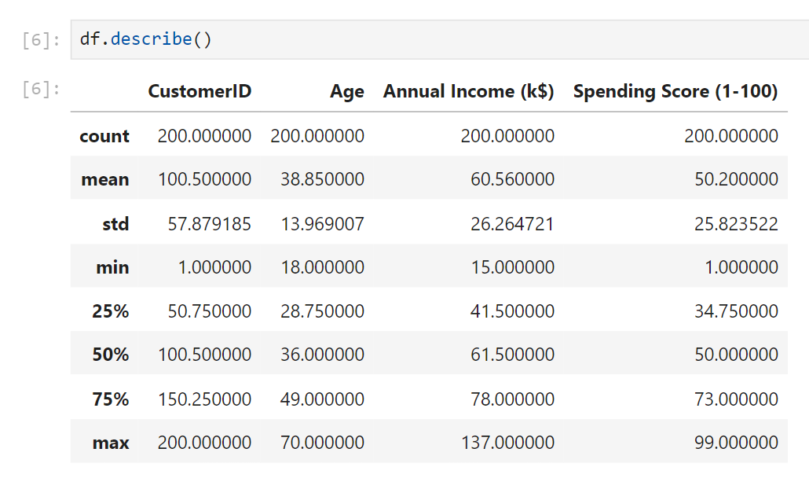
It describes about the count which counts the no of rows in it, mean of the columns, standard deviations, maximum and minimum and percentiles etc. From the statistics
The mean age of customers is 38.85 years.
The average annual income is $60.56k
The average spending score is 50.20
17
6.2. Gender Distribution
Here a count plot is used to visualize the distributions of customers by gender.
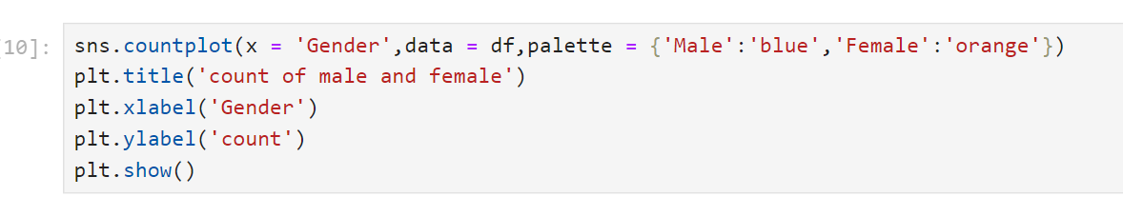
We label the x-axis as Gender and y-axis as count.

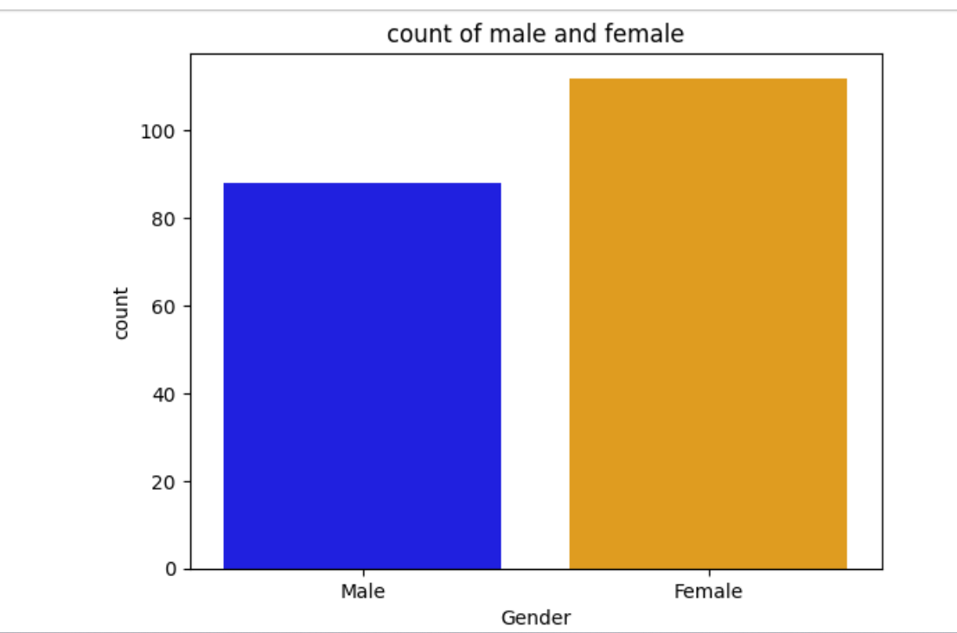
From the plot we come to a conclusion that the female customers purchase more than the male customers that is ,female customers are more than 100 whereas male customers are nearly 80.

18
6.3. Age Distribution
We will use distplot to visualize the distribution of age of the customers.
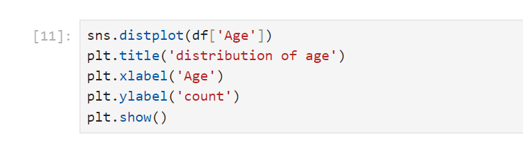
Here we label x-axis as Age (range of age) and y-axis as Count.
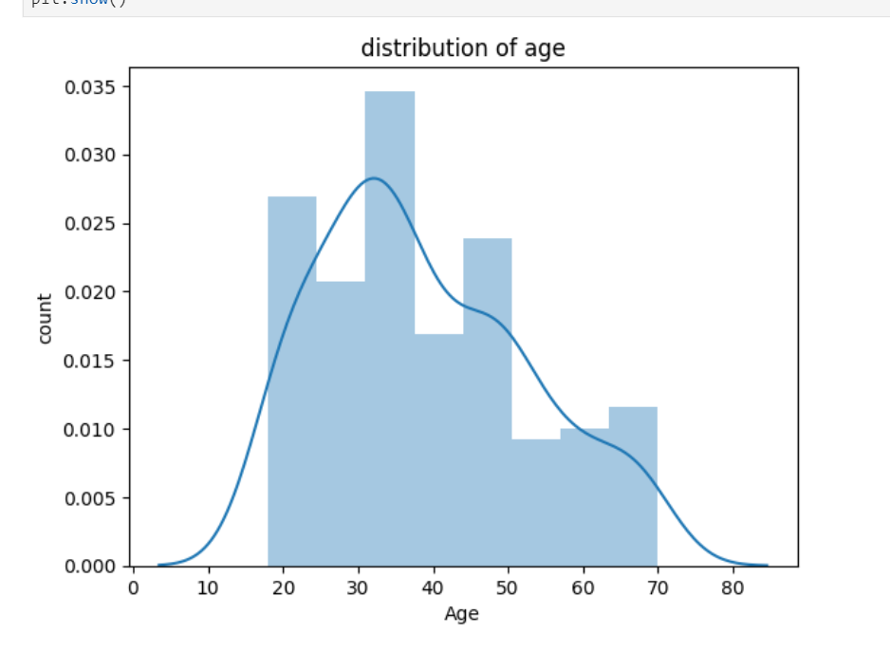
From the plot, the age varies from nearly 20 to 70 years. The highest count indicates that customers between the age group 30-40 years are more than 20-30 years. Our customers are young or middle aged. Here the plot is right-skewed which means more young customers than older customers.

19
6.4 Distribution of Annual Income
Here we visualize the distribution of annual income of customers. We take x-axis as Annual Income (in k$) and y-axis as count.
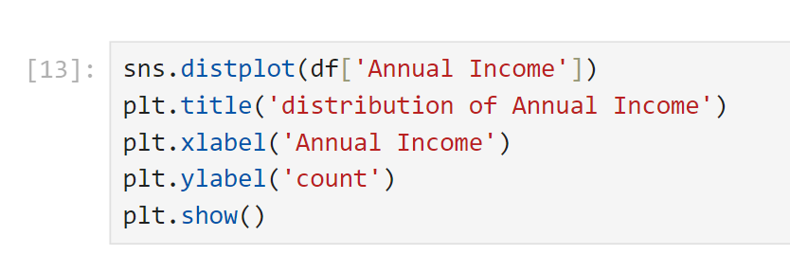
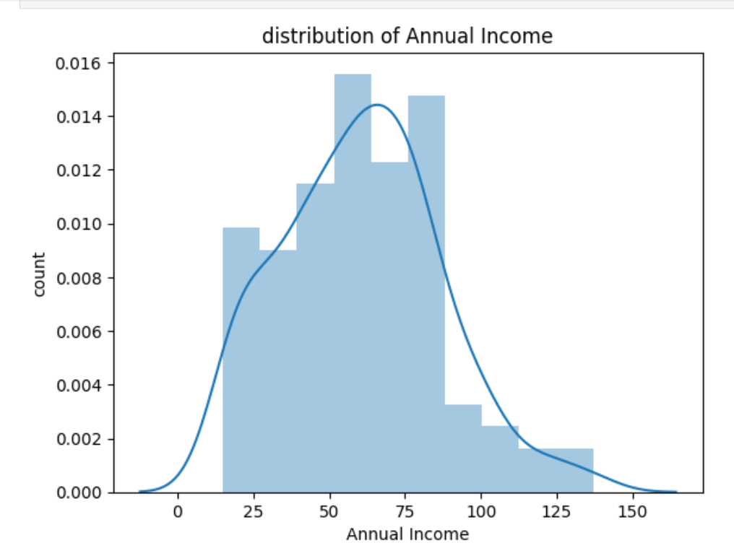
From the plot, the income varies from nearly 25 to 125 k$. The highest count indicates that common income of majority of customers is 50k$ . Here the plot is right-skewed which means most of them have lower or moderate income and some of them have higher income.

20
6.5 Distribution of Spending Score
Here we visualize the distribution of spending score of customers. We take x-axis as Spending Score ( from 1-100) and y-axis as count.
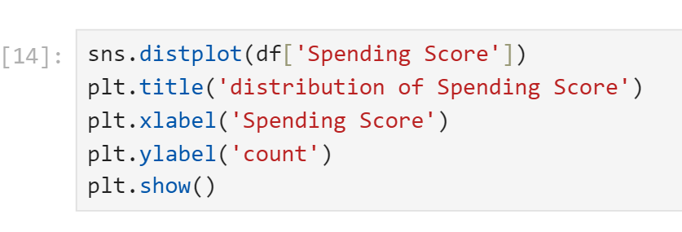
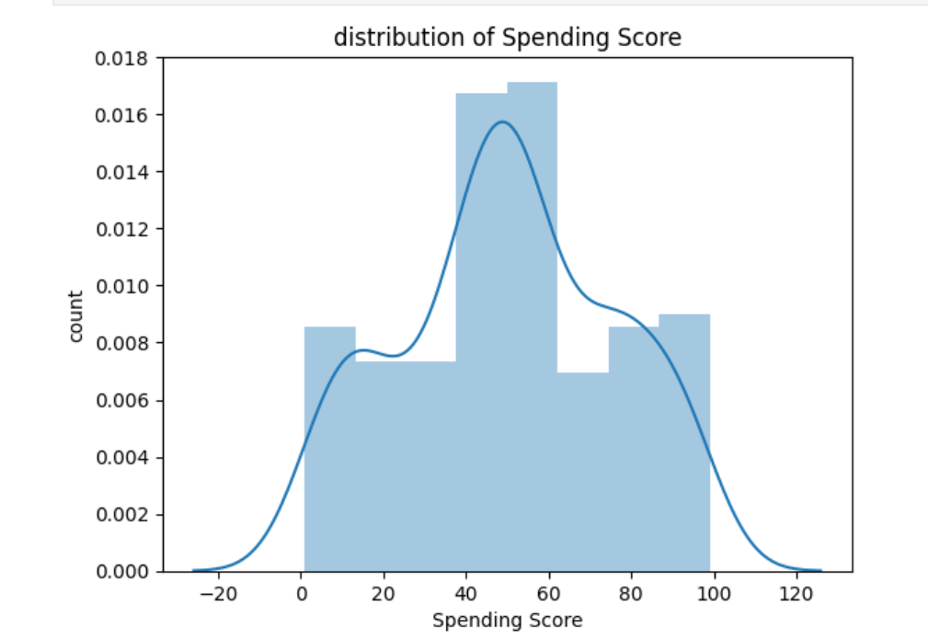
From the plot, the spending score ranges from 0-100. The plot shows a significant number of customers have spending scores between 40 and 60, which means that many customers fall within this behaviour category. In this plot fewer customers have either very low(below 20) or very high spending score(above 100).
21
6.6 Correlation Analysis
A correlation matrix is a table showing correlations between variables. A heatmap is generated to visualize a correlation matrix to observe the correlation between Age, Annual Income, and Spending Score, indicating which variables are most related.
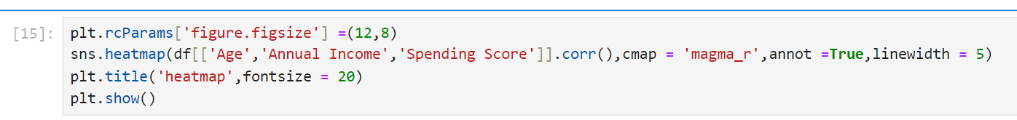

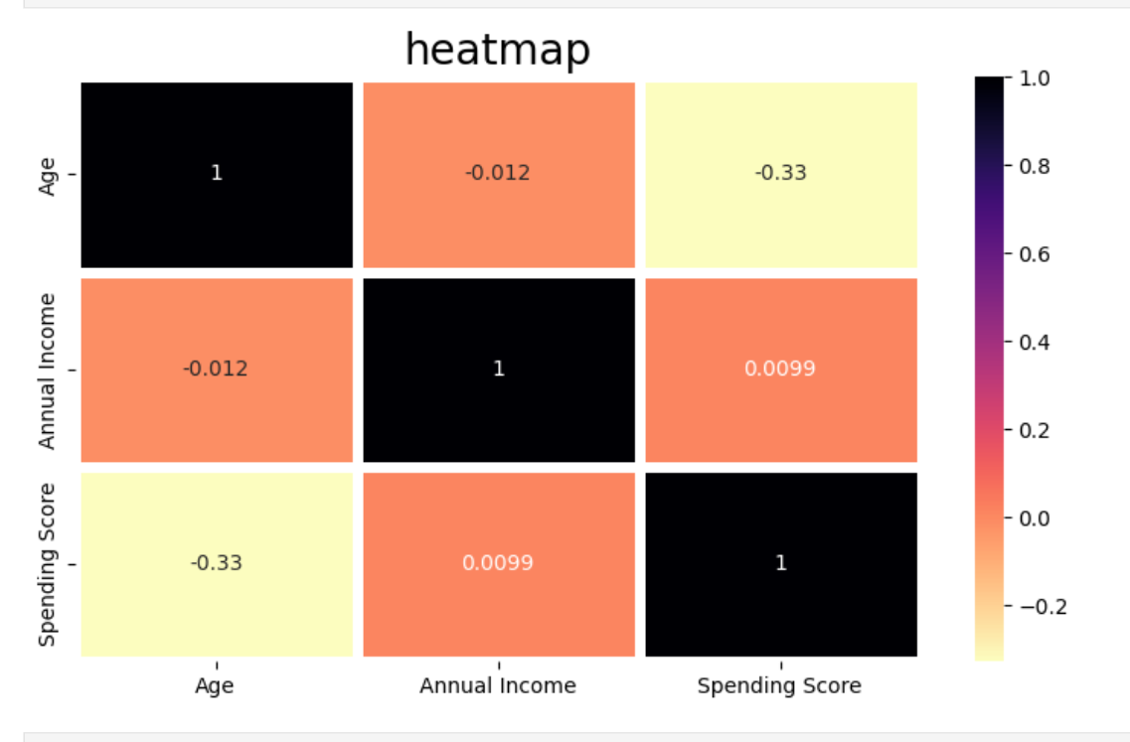
Based on correlation analysis , we get annual income and spending score correlates to each other with a good score.
6.7. Comparison between Gender and Spending Score
To understand the difference in spending score between male and females, we generate a violin plot .

22
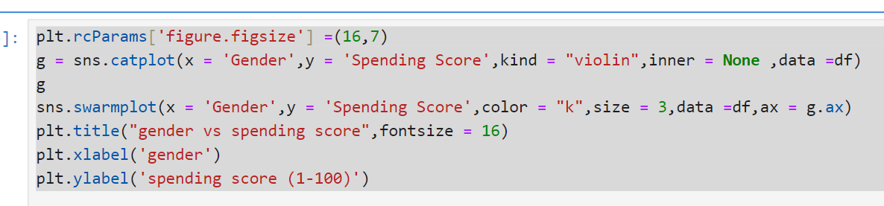
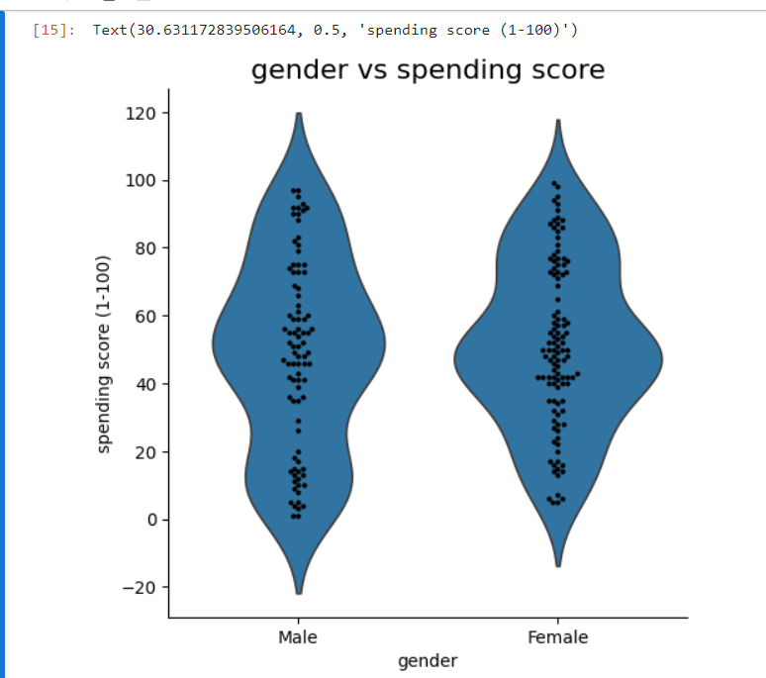
From the plot it clear that females have more spending score than males. That is females spends more in purchasing than men.
  - Comparison between Gender and Annual Income
Here we understand the relationship between male and female and their annual income.

23
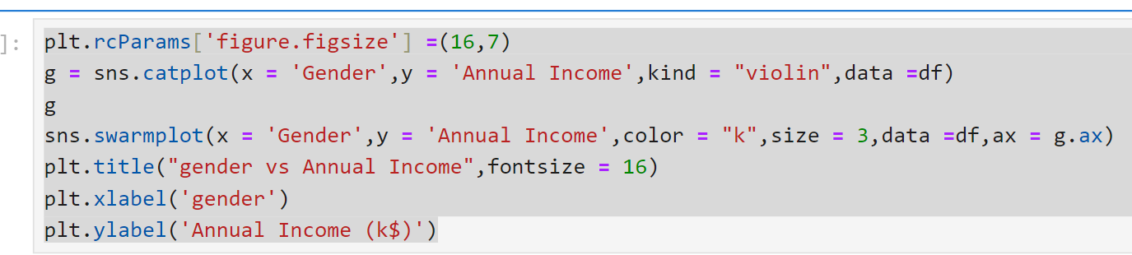
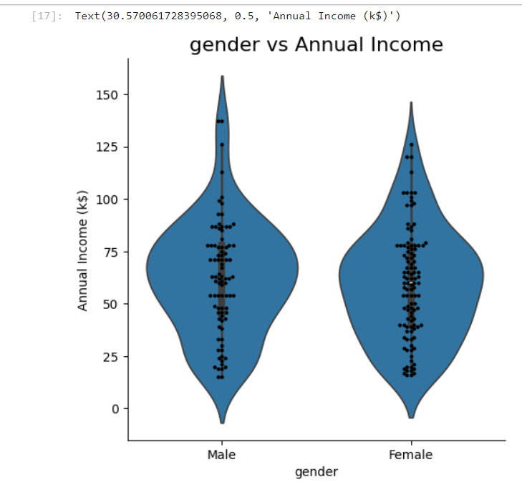
The plot shows males have more annual income than female. Which means the salary of male is higher than that of female.

24
6.9. Comparison between Gender and Age
To visualize the relationship between Gender and Age we will generate a box plot.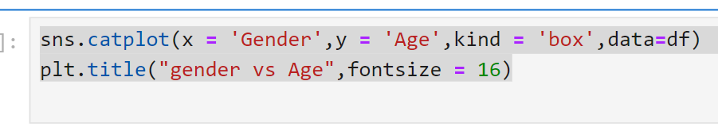
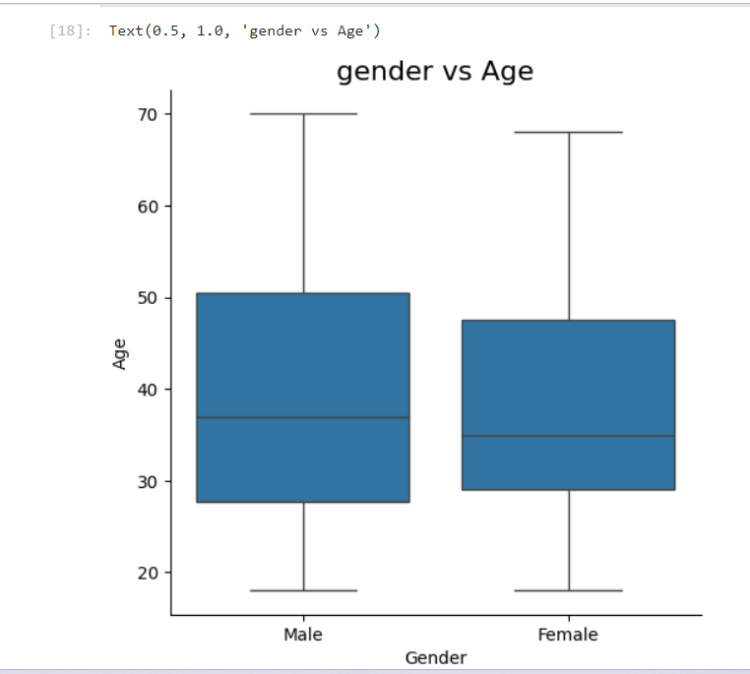
In the plot the median is quite similar for male and female(around 35 – 40years).The interquartile range of both gender are around in 30-50 years range. The maximum and minimum for both customers are 20 and 70 years.

25
We come to an conclusion that both male and female have similar age distribution with no major differences in their range and median. Since most of the customers fall within 30-50 years age group for both men and women. It means that this age group is making most purchases in both genders.
7. Clustering Process
  - Clustering with Two Features
7.1.1. Feature Selection
Feature Selection is a critical step in identifying the most relevant variables that contribute to the customers segmentation process. For this clustering we select Annual Income and Spending Score as two features. 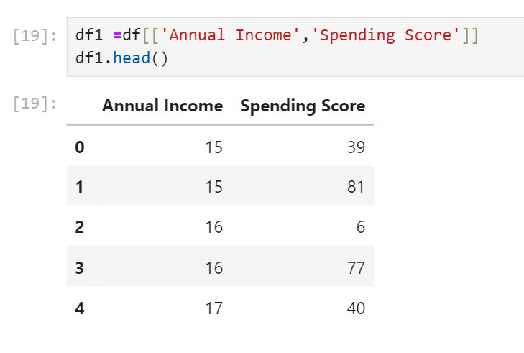
7.1.2. Determining the optimal number of clusters
The Within- Cluster Sum of Squares(WCSS) was calculated for different values of k (number of clusters) . The Elbow Method was applied to determine the optimal number of clusters by plotting the WCSS. The point where the WCSS begins to decrease at a rate is chosen for the optimal number of cluster for segmenting the data.
26
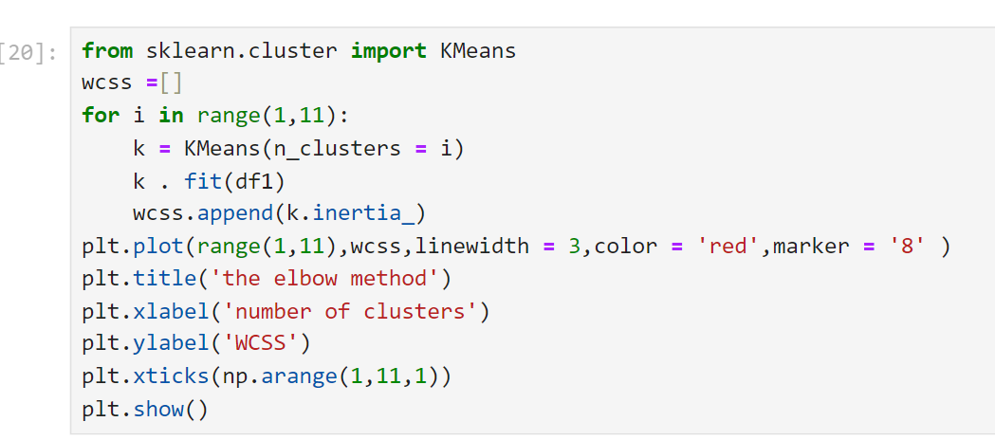
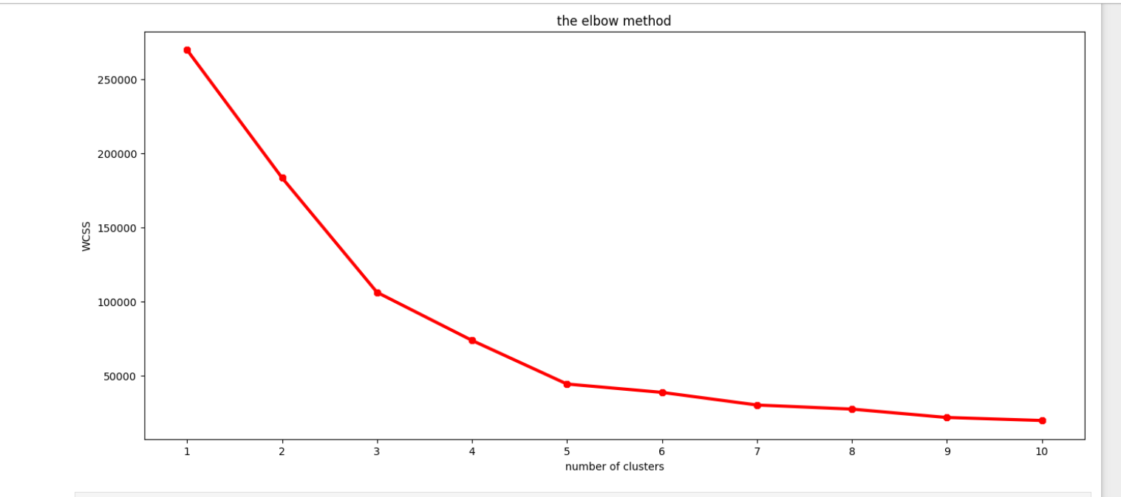
So from the graph we observed that the at 5 there is a bend and it can be considered as k which is no of clusters.
Therefore, k = 5 i.e . The optimal number of clusters is found to be 5.
7.1.3. Applying K-Means Clustering
With the optimal number of clusters k determined , next we apply k- means algorithm to group customers into distinct clusters based on selected features. Then we will predict the data and store it in y. And then we will add new column named as Label and data as y.

27
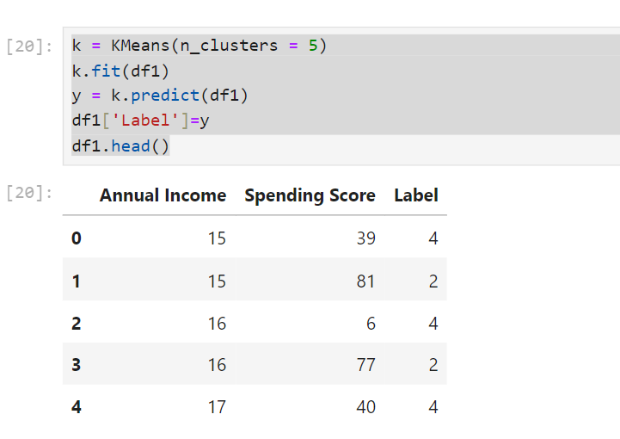
After running the K- means algorithm the dataset was updated with a new column ‘Label’ which indicates the cluster labels for each clusters.
7.1.4 Visualization
To visually interpret the clusters , a Scatter Plot is generated with the features Annual Income and Spending Score with each point color-coded by its assigned cluster label . This helps in visualizing the separation between different customer segments.

sns.scatterplot(x = 'Annual Income', y = 'Spending Score', data = df1, hue='Label', s =100, palette =['red', 'green', 'brown', 'blue', 'orange'])
plt.title('segmentation of customers based on 2 features')

28
  - Clustering with Three Features
7.2.1. Feature Selection
For this clustering we select Annual Income , Spending Score and Age as three features.
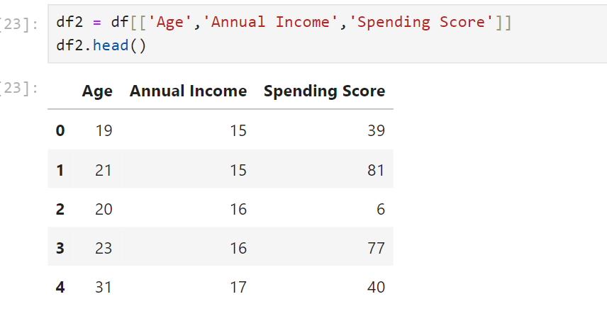
7.2.2 Determining the optimal number of clusters
The method discussed for two features is same for three features

29
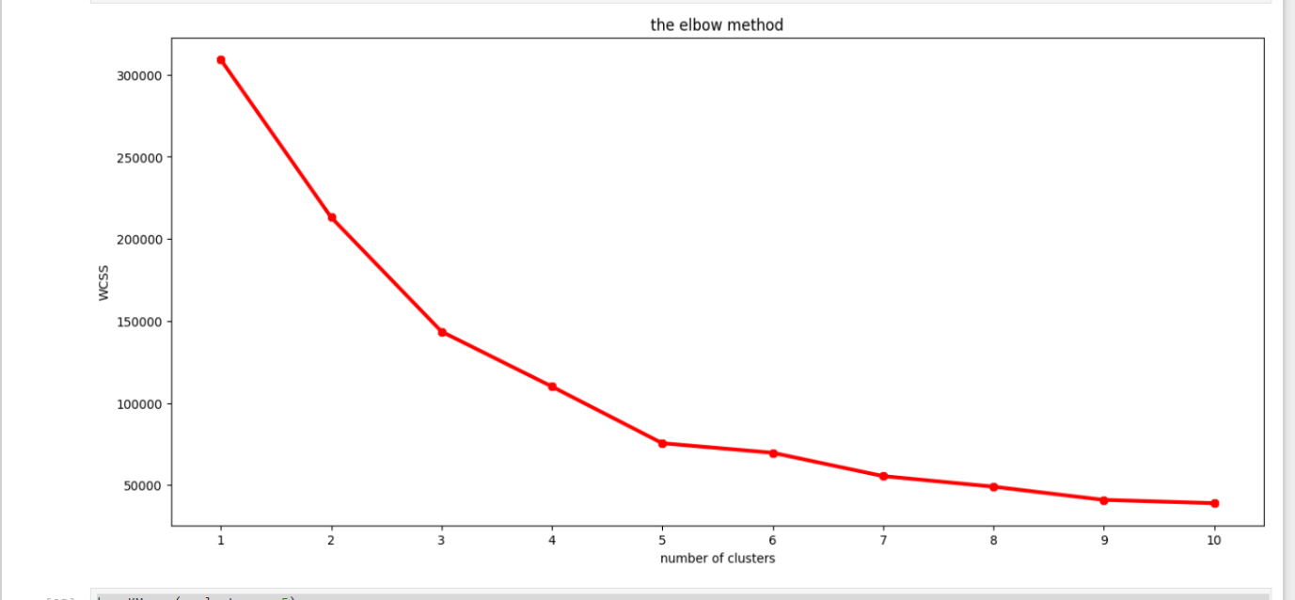
Here k = 5. The optimal cluster is still 5.
7.2.3. Applying K-Means Clustering
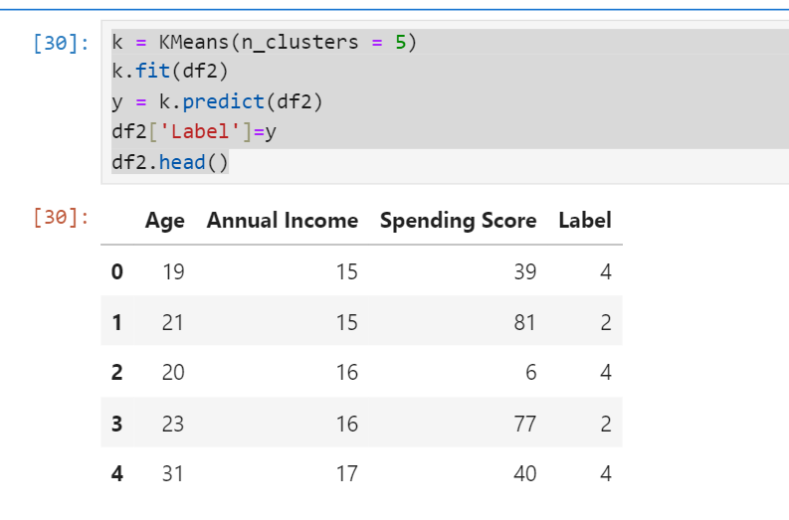

30
7.2.4 Visualization
To visually interpret the clusters , a 3D-Scatter Plot is generated with the features Annual Income, Spending Score and Age with each point color-coded by its assigned cluster label.

In this plot, each axis represents one of selected features. This 3D representation helps in identifying the distinct clusters formed by the K-means algorithm, revealing how customers with similar income ,spending behaviour and age group together . This helps in visualizing the separation between different customer segments.
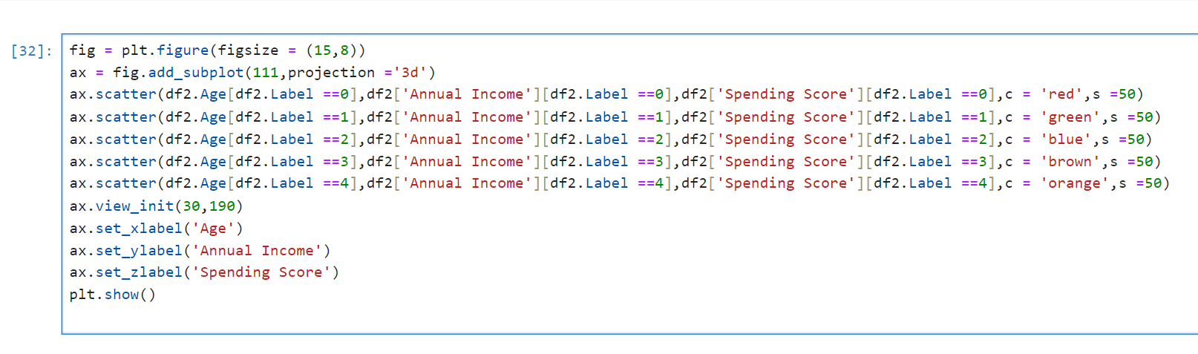
- Principal Component Analysis
Since visualizing 3D plots can be difficult , so we use principal component analysis (PCA) for better visualization. With the 3 features, PCA reduces the data to 2 components: PCA1 & PCA2.

31
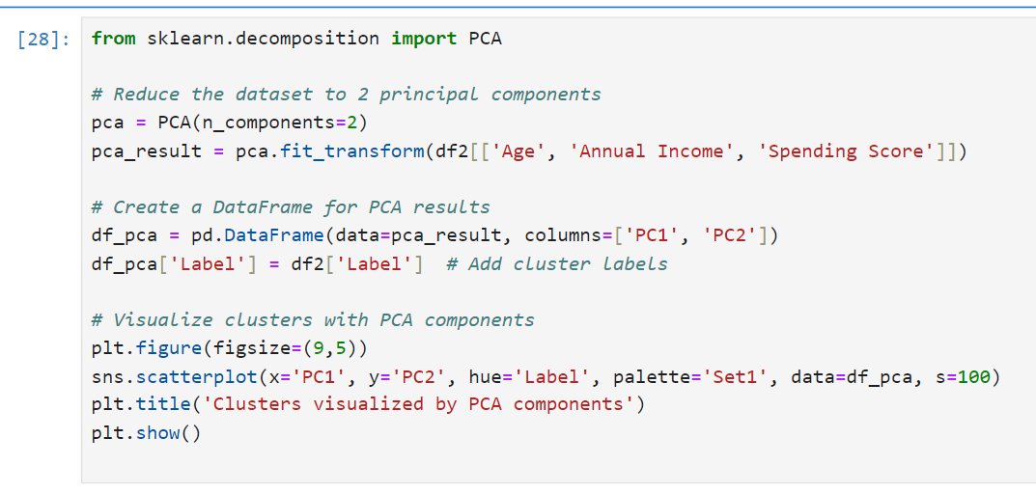
The resulting plot is similar to 2D scatterplot making it easier to interpret the clusters.

32
CHAPTER 5: RESULTS AND INSIGHTS
We now present the results of our project Customer Segmentation Analysis. Here we used k-means clustering algorithm for grouping the customers into distinct clusters and by using elbow method we got 5 clusters as optimal for segmentation.
First we performed clustering based on two features: Annual Income and Spending Score
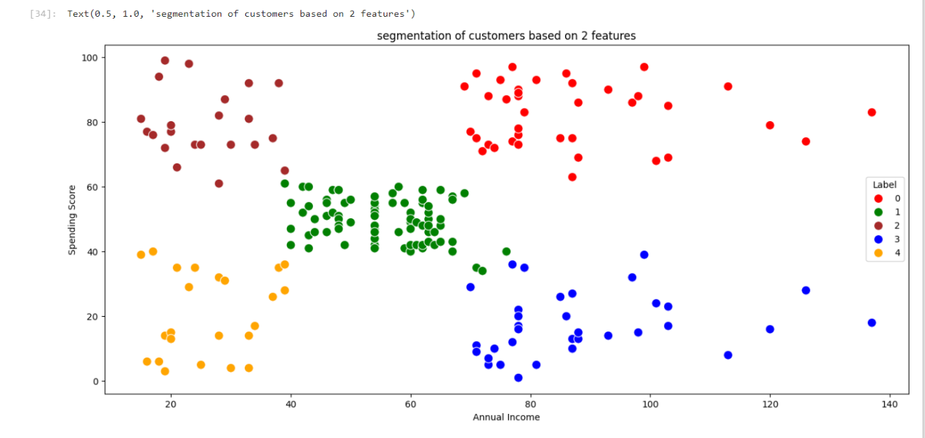
So from the above scatter plot we observed that the there are 5 clusters which are named as 0, 1, 2, 3, 4.
- Label 0 at top right indicates highest annual income with highest spending score
- Label 1 at centre of the plot indicates average annual income with average spending score.
- Label 2 at top left of the plot indicates lowest annual income with highest spending score
- Label 3 at bottom right indicates highest annual income with lowest spending score.
- Label 4 at bottom left indicates lowest annual income with lowest spending score.

33
Second we performed clustering based on three features: Annual Income Spending Score and Age.
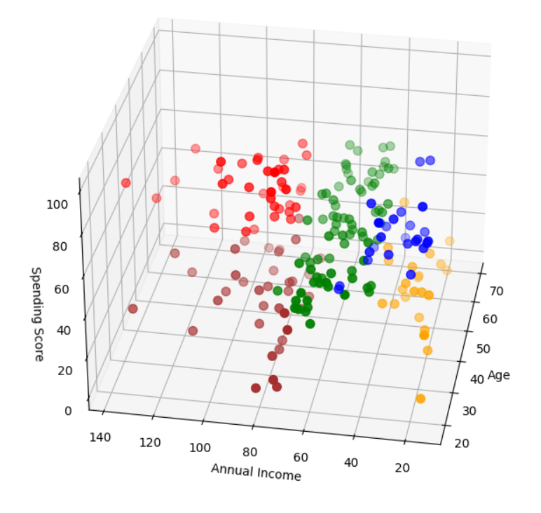In the above 3D scatter plot we observe there are 5 clusters . To understand what each clusters interpret in the above 3D we performed mean analysis of the above features.

34
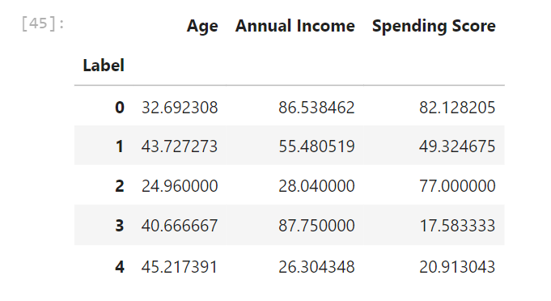
From the above result we interpret the 5 clusters as:
- Label 0 (Red) indicates that highest annual income with high spending score and age may indicate young customers.
- Label 1 (Green) indicates the moderate annual income with average spending score and they are middle-aged customers.
- Label 2 (Brown) indicates low annual income with high spending score and they are younger customers.
- Label 3 (Blue) indicates high annual income with low spending score and they are middle-aged customers.
- Label 4 (Orange) indicates low annual income with low spending score and it mainly consist of middle aged or older customers.

35
To better visualize the clusters we have PCA plot which is similar to 2D scatterplot.

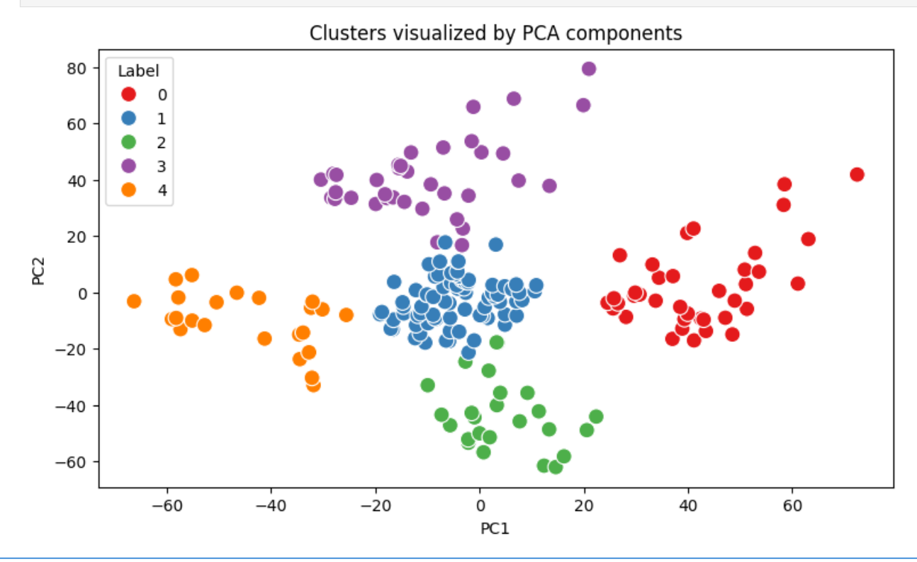
From the plot it is clear that PCA1 ranges from -60 to 60 and PCA2 ranges from -60 to 80 . We can interpret these clusters based on the mean analysis of the feature. We get the same results that of the 3D scatterplot.
- Red cluster (Label 0) indicates that highest annual income with high spending score and age may indicate young customers.
- Blue cluster (Label 1) indicates the moderate annual income with average spending score and they are middle-aged customers.
- Green cluster (Label 2) indicates low annual income with high spending score and they are younger customers.
- Purple cluster (Label 3) indicates high annual income with low spending score and they are middle-aged customers.
- Orange cluster (Label 4 ) indicates low annual income with low spending score and it mainly consist of middle aged or older customers.
This provides simpler representation compared to 3D scatterplot.

36
From the above 2D & 3D scatter plot and also from PCA plot it is clear that Annual Income and Spending Score are the primary drivers in defining customer segments. Age can be helpful as secondary factor to further understand the customer but doesn’t have impact on segmenting.
The feature Annual Income was chosen as it represents the financial capability of customers. Income levels often correlate with purchasing making it a key factor in distinguishing between different customer segments
The Spending Score is a valuable measure of customer behaviour, reflecting how much customers tend to spend. This feature is essential for differentiating between high spending and low spending, which is important for creating segments.

37
CHAPTER 6: CONCLUSION
  - Summary of Insights
We begin this project with the goal to perform customer segmentation with k-means algorithm in python in simplest way and also with the goal of how market strategy can be applied in our target customers. We performed k-means clustering based on Annual Income ,Spending Score and Age. From that we came to conclusion that Annual Income and Spending Score pays main role in segmenting customers. The results revealed five customer segments each with unique spending patterns and income characteristics .
From 2D and 3D plot we can concluded that the ,
- The Highest income , high spending are the premium customers with both financial means and willingness to spend. They are likely to look for quality and luxury products.
- Highest income, low spending are the customers have high income and not willing to spend more. They may be focused on saving instead of spending
- Average income, Average spending are the customers that are likely to be budget-conscious. They may need some push to increase their spending score.
- Low income, High spending are the customers that are willing to spend but has low income. They may focus on good deals, quality and practically .
- Low income, Low spending are the customers that are budget-conscious with limited disposable income. They may need some significant push to spend more, focussing on price over quality.
5.2 Recommendations
Here we present the market strategies and our target customers.
From the above insights our main target customers for any business are usually the group high income with high spending.

38
Because this customers are willing to spend more , we target them to focus on premium products, exclusive memberships and luxury services
The market strategy can be used for other groups such in high income and low spending we can provide long-term such as quality or investment opportunities. We can target these customers by asking feedback and advertising the product in a better way.
low income and high spending can be targeted . We can use promotional strategies that will reward customers for continued engagement(like cashback offers)
Average income, Average spending may or may not be beneficial to the mall owners of this type of customers. We can encourage them for more purchases by promotions, discounts and bundle of offers
In Low income, Low spending market don’t target these type of customers because they earn a bit and spend some amount of money. We can provide budget-friendly products ,flexible payment options .Focus on essential items they need rather than luxury or non-essential products.
5.3 Limitations of k-means clustering
- Fixed number of clusters: K-means requires the user to predefine the number of clusters K which may not be optimal without prior knowledge
- Assumption of spherical clusters: K-means assumes clusters are spherical and equally sized, which doesn’t work well with non-spherical or unevenly distributed data.
- Not robust to outliers: Outliers can significantly distort clusters centres, affecting the quality of the clustering.
- Only works with numerical data: K-means uses distance measures, so it is not suitable for categorical data or mixed-type data without preprocessing.
- Sensitivity to scale: If the features have different scales, k-means can be biased toward the features with larger ranges, requiring normalization or standardization.

39
5.4 Future work
While the current analysis has successfully segmented customers based on available data, there are several opportunities to extend and enhance this work. By addressing certain limitations and exploring additional methods ,future research can provide deeper insights and further improve the effectiveness of customer segmentation.

- You can explore advanced clustering techniques like DBSCAN, hierarchical clustering or Gaussian Mixture Models to improve segmentation quality ,especially for non-spherical clusters. Also this method is useful in deciding the number of clusters as no need to predefine K.
- Future work could include additional features like location,product preference. These additional features would refine the segmentation providing deeper insights and enabling more precise targeting strategies.
- Incorporating behavioural data such as purchase frequency, types of products brought or browsing history would allow for more understanding of customer segmentation. This could lead better tailored marketing strategies that address specific behaviours rather than just demographic attributes.
- Incorporating customer feedback and satisfaction scores could provide valuable insights into the quality of service or product perferences. This data could be used to segment customers based on how they perceive the business, allowing more customer-centric improvements.

40
REFERENCES
[1] Sari Juni Nurma, Nugroho, Lukito. Edi, Ferdiana, Ridi & Santosa, P. Insap (2016).“Review on Customer Segmentation Technique on Ecommerce”. Advanced Science Letters, vol 22, No(10), 3018–3022.
https://doi.org/10.1166/asl.2016.7985
[2] Chenguang Wang (2022).”Efficient Customer Segmentation in digital marketing using Deep Learning with Swarm Intelligence Approach”. Information Processing and Management, vol 59, issue 6, 0306-4573.
https://doi.org/10.1016/j.ipm.2022.103085
[3] Rahma Wah Sembring Brahama, Fahd Agodzo Mohammed, Kankamol Chairuong (2020).”Customer Segmentation based on RFM model using K-Means , K-Medoids and DBSCAN methods”. Lontar Komputer Jurnal Ilmiah Teknology Informasi, vol 11, 2541-5832.
https://doi.org/10.24843/LKJITI2020.vll.io1.p04.
[4] Eman Hussein .Sharaf Addin, Novia Admodisastro, Siti Nur Syahirah, M. Ashri, Azrina Kamaruddin Yew C. Chong(2022). “Customer Mobile Behavioural Segmentation and Analysis in Telecom Using Machine Learning”. Applied Artificial Intelligence, vol 36, 2022, Issue 1
https://doi.org/10.1080/08839514.2021.2009223
[5] M. A. Syakar, B. K. Khotimah , EMS Rochman, B. D. Satoto(2018)”Integration K-Means Clustering Method and Elbow Method for identification of the best customer profile cluster”. IOP Conference Series: Materials Science and Engineering ,vol 336
https://doi.org//10.1088/1757-899X/336/1/012017
[6] Mediana Aryuni, Evaristus Didik Madyatmadja, Eka Miranda(2018) “Customer Segmentation in XYZ Bank using K-Means and K-Meiods Clustering”. International Conference on Information Management and Technology(ITCM Tech)
https://doi:10.1109/ICIMTech.2018.8528086
41
[7] Jaypee University of Information Technology “Customer Segmentation.pdf “ (2022)
http://www.ir.juit.ac.in:8080/jspui/bitstream/123456789/3607/1/Customer Segmentation.pdf
[8] Customer Segmentation using K-Means Clustering with Python | Machine Learning Projects (2021)
https://youtu.be/SrY0sTJchHE

42

